Antarmuka & Peripheral

Tugas Pertemuan 2



Nama : Irawan

NIM : 0901128621057

Kelas : SK7B

Dosen Pengampuh : Rendyansyah S.Kom., M.T.

Jurusan Sistem Komputer

Fakultas Ilmu Komputer

Universitas Sriwijaya

2018

Tugas :

Antarmuka:

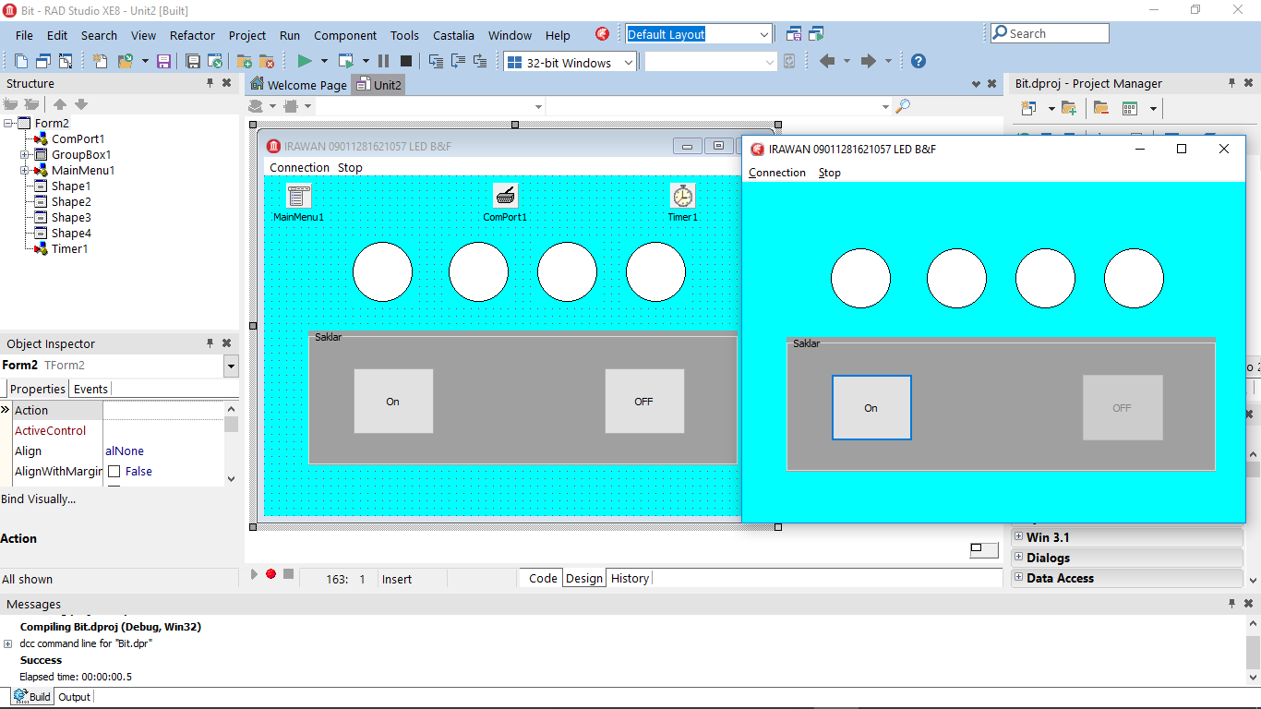

Code antarmuka:

unit Unit2;//Irawan 09011281621057 SK7B

interface

uses

Winapi.Windows, Winapi.Messages, System.SysUtils, System.Variants, System.Classes, Vcl.Graphics,

Vcl.Controls, Vcl.Forms, Vcl.Dialogs, Vcl.Menus, Vcl.StdCtrls, Vcl.ExtCtrls,

CPort;

type

led_array = array[0..8]of integer;

TForm2 = class(TForm)

MainMenu1: TMainMenu;

Connection1: TMenuItem;

Setting1: TMenuItem;

Connect1: TMenuItem;

Stop1: TMenuItem;

Exit1: TMenuItem;

ComPort1: TComPort;

GroupBox1: TGroupBox;

Button1: TButton;

Button2: TButton;

Timer1: TTimer;

Shape1: TShape;

Shape2: TShape;

Shape3: TShape;

Shape4: TShape;

procedure Exit1Click(Sender: TObject);

procedure Button1Click(Sender: TObject);

procedure Button2Click(Sender: TObject);

procedure Setting1Click(Sender: TObject);

procedure Connect1Click(Sender: TObject);

procedure status_led(led:led_array);

procedure Stop1Click(Sender: TObject);

procedure Timer1Timer(Sender: TObject);

procedure FormCreate(Sender: TObject);

private

{ Private declarations }

public

{ Public declarations }

left:integer;

right:integer;

end;

var

Form2: TForm2;

hitung1:integer;

implementation

{$R *.dfm}

procedure TForm2.Button1Click(Sender: TObject);

begin

if button1.Caption='On' then

Begin

left:=1;

right:=0;

Timer1.Enabled:=True;

button1.Enabled:=False;

button2.Enabled:=True;

end;

end;

procedure TForm2.Button2Click(Sender: TObject);

begin

if button1.Caption='On' then

Begin

Timer1.Enabled:=False;

button1.Enabled:=True;

button2.Enabled:=False;

end;

end;

procedure TForm2.Connect1Click(Sender: TObject);

begin

Comport1.Open();

Comport1.Connected := True

end;

procedure TForm2.Exit1Click(Sender: TObject);

begin

Application.Terminate

end;

procedure TForm2.FormCreate(Sender: TObject);

begin

Button2.Enabled:=False;

hitung1:=0;

end;

procedure TForm2.Setting1Click(Sender: TObject);

begin

comport1.ShowSetupDialog()

end;

function pangkat(b:integer):Integer;

var

i,a:Integer;

begin

a:=1;

for i := b downto 1 do

begin

a:=a*2;

end;

pangkat:=a;

end;

procedure TForm2.status_led(led:led_array);

begin

if led[0]=1 then

begin

Shape1.Brush.Color:=clRed;

end

else

begin

Shape1.Brush.Color:=clWhite;

end;

if led[1]=1 then

begin

Shape2.Brush.Color:=clRed;

end

else

begin

Shape2.Brush.Color:=clWhite;

end;

if led[2]=1 then

begin

Shape3.Brush.Color:=clRed;

end

else

begin

Shape3.Brush.Color:=clWhite;

end;

if led[3]=1 then

begin

Shape4.Brush.Color:=clRed;

end

else

begin

Shape4.Brush.Color:=clWhite;

end;

end;

procedure TForm2.Stop1Click(Sender: TObject);

begin

Comport1.Close();

Comport1.Connected := False

end;

procedure TForm2.Timer1Timer(Sender: TObject);

var

led:led_array;

a,b:integer;

nbit:integer;

begin

b:=hitung1;

if (left=1) and (b<8) then

begin

b:=b shl 1;

if b=0 then

begin

b:=1;

end;

hitung1:=b;

if b=8 then

begin

left:=0

end

end

else if (b=8) or (left=0) then

begin

b:=b shr 1;

hitung1:=b;

if b=1 then

begin

b:=1;

left:=1;

end;

end

else

begin

b:=1;

hitung1:=b;

end;

ComPort1.WriteStr(IntToStr(hitung1)+#13);

nbit:=7;

while nbit>=0 do

begin

a:=pangkat(nbit);

if a=b then

begin

led[nbit]:=1;

end

else

begin

led[nbit]:=0;

end;

nbit:=nbit-1;

end;

status_led(led);

end;

end.

Code CVAVR:

/*****************************************************

This program was produced by the

CodeWizardAVR V2.05.0 Evaluation

Automatic Program Generator

© Copyright 1998-2010 Pavel Haiduc, HP InfoTech s.r.l.

http://www.hpinfotech.com

Project :

Version :

Date : 04/09/2019

Author : Freeware, for evaluation and non-commercial use only

Company :

Comments:

Chip type : ATmega8535

Program type : Application

AVR Core Clock frequency: 8,000000 MHz

Memory model : Small

External RAM size : 0

Data Stack size : 128

*****************************************************/

#include <mega8535.h>

#include <delay.h>

// Standard Input/Output functions

#include <stdio.h>

// Declare your global variables here

void main(void)

{

// Declare your local variables here

int a;

// Input/Output Ports initialization

// Port A initialization

// Func7=In Func6=In Func5=In Func4=In Func3=In Func2=In Func1=In Func0=In

// State7=T State6=T State5=T State4=T State3=T State2=T State1=T State0=T

PORTA=0x00;

DDRA=0x00;

// Port B initialization

// Func7=In Func6=In Func5=In Func4=In Func3=In Func2=In Func1=In Func0=In

// State7=T State6=T State5=T State4=T State3=T State2=T State1=T State0=T

PORTB=0x00;

DDRB=0x00;

// Port C initialization

// Func7=Out Func6=Out Func5=Out Func4=Out Func3=Out Func2=Out Func1=Out Func0=Out

// State7=0 State6=0 State5=0 State4=0 State3=0 State2=0 State1=0 State0=0

PORTC=0x00;

DDRC=0xFF;

// Port D initialization

// Func7=In Func6=In Func5=In Func4=In Func3=In Func2=In Func1=In Func0=In

// State7=T State6=T State5=T State4=T State3=T State2=T State1=T State0=T

PORTD=0x00;

DDRD=0x00;

// Timer/Counter 0 initialization

// Clock source: System Clock

// Clock value: Timer 0 Stopped

// Mode: Normal top=0xFF

// OC0 output: Disconnected

TCCR0=0x00;

TCNT0=0x00;

OCR0=0x00;

// Timer/Counter 1 initialization

// Clock source: System Clock

// Clock value: Timer1 Stopped

// Mode: Normal top=0xFFFF

// OC1A output: Discon.

// OC1B output: Discon.

// Noise Canceler: Off

// Input Capture on Falling Edge

// Timer1 Overflow Interrupt: Off

// Input Capture Interrupt: Off

// Compare A Match Interrupt: Off

// Compare B Match Interrupt: Off

TCCR1A=0x00;

TCCR1B=0x00;

TCNT1H=0x00;

TCNT1L=0x00;

ICR1H=0x00;

ICR1L=0x00;

OCR1AH=0x00;

OCR1AL=0x00;

OCR1BH=0x00;

OCR1BL=0x00;

// Timer/Counter 2 initialization

// Clock source: System Clock

// Clock value: Timer2 Stopped

// Mode: Normal top=0xFF

// OC2 output: Disconnected

ASSR=0x00;

TCCR2=0x00;

TCNT2=0x00;

OCR2=0x00;

// External Interrupt(s) initialization

// INT0: Off

// INT1: Off

// INT2: Off

MCUCR=0x00;

MCUCSR=0x00;

// Timer(s)/Counter(s) Interrupt(s) initialization

TIMSK=0x00;

// USART initialization

// Communication Parameters: 8 Data, 1 Stop, No Parity

// USART Receiver: On

// USART Transmitter: Off

// USART Mode: Asynchronous

// USART Baud Rate: 9600

UCSRA=0x00;

UCSRB=0x10;

UCSRC=0x86;

UBRRH=0x00;

UBRRL=0x33;

// Analog Comparator initialization

// Analog Comparator: Off

// Analog Comparator Input Capture by Timer/Counter 1: Off

ACSR=0x80;

SFIOR=0x00;

// ADC initialization

// ADC disabled

ADCSRA=0x00;

// SPI initialization

// SPI disabled

SPCR=0x00;

// TWI initialization

// TWI disabled

TWCR=0x00;

while (1)

{

// Place your code here

scanf("%d",&a);

PORTC = a;

delay_ms(100);

}

}